Chapter 5

Riding the Carabao

*How does this sound: meet up at the Hammock hotel for some local moonshine. Choose your carabao, get on it and ride up among the rolling hills of Siargao. All this while enjoying unlimited rum and beer. We stop on a hilltop for pictures and carabao racing. This is truly a day to remember, or not ? [1]*

*Now that we mastered the basics of Carabao we are ready to rise to the fun level – "Riding the Carabao" - which means fully leveraging the draft conceptual power of the Carabao class design for data analysis requirements.*

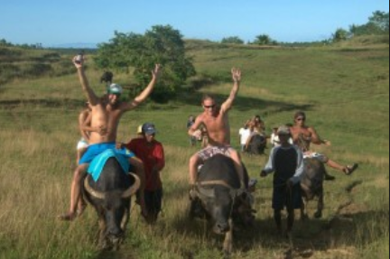If you don't live in Malaysia, on the Philippines or other related countries in what a carabao is, but you can associate much more with the word 'carabao' if I tell you that a carabao is a swamp-type domestic water buffalo. Philippine farmers leverage carabaos as a source of draft animal power and live from their meat and milk. They use carabaos as strong and robust 'working engines' for their basic farming tasks, like drawing sledges, carriages or a plugs. The farmers guide a group of carabaos in trampling the planting area until it is soggy enough to receive the rice seedlings. Last but not least you can ride a carabao, and you should be noted that every Philipine farmer kid is skilled to ride a carabao.

# References

[1] *Drunken Carabao Tour*: http://siargaophilippines.com/drunken-carabao-tour/